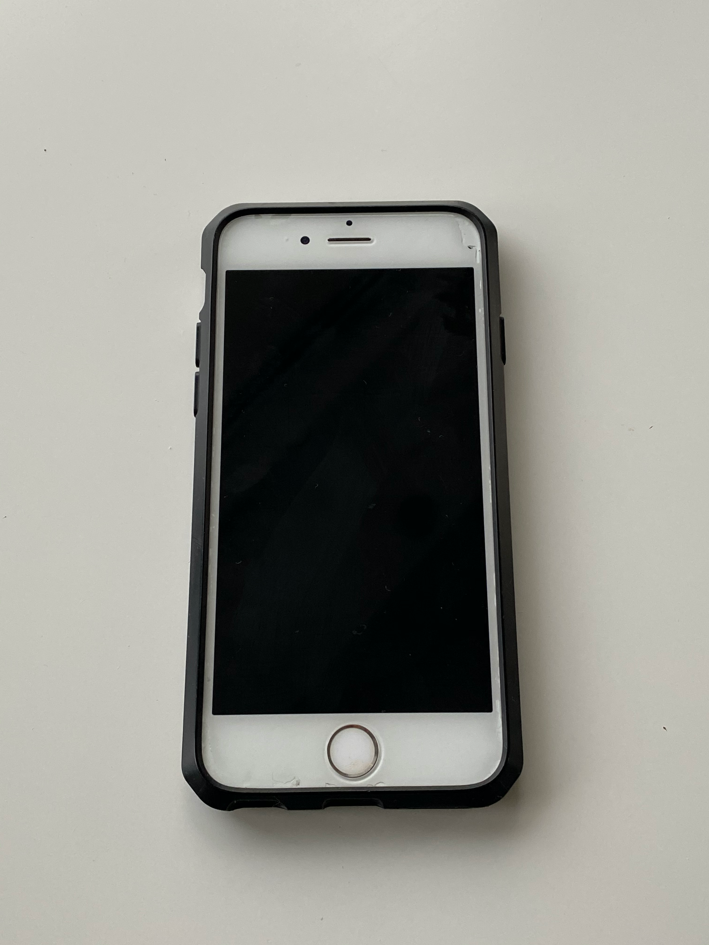
iPhone 6S

